**2019-06-22: Brian Labelle Submission of Unit 2 | Assignment - The VBA of Wall Street**  
**2014**  
  
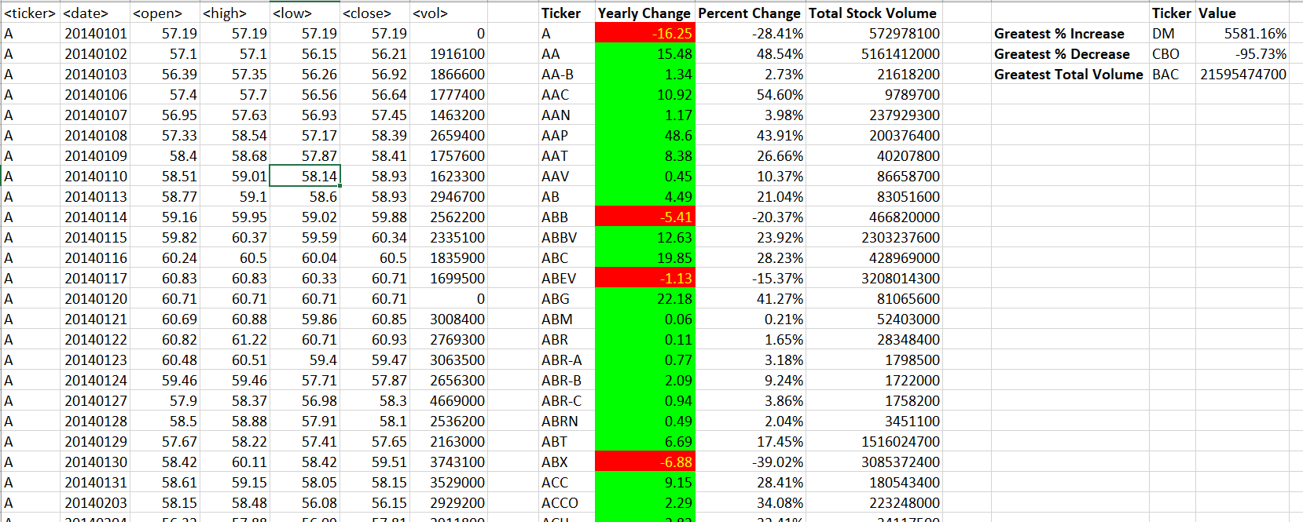

**2015**  
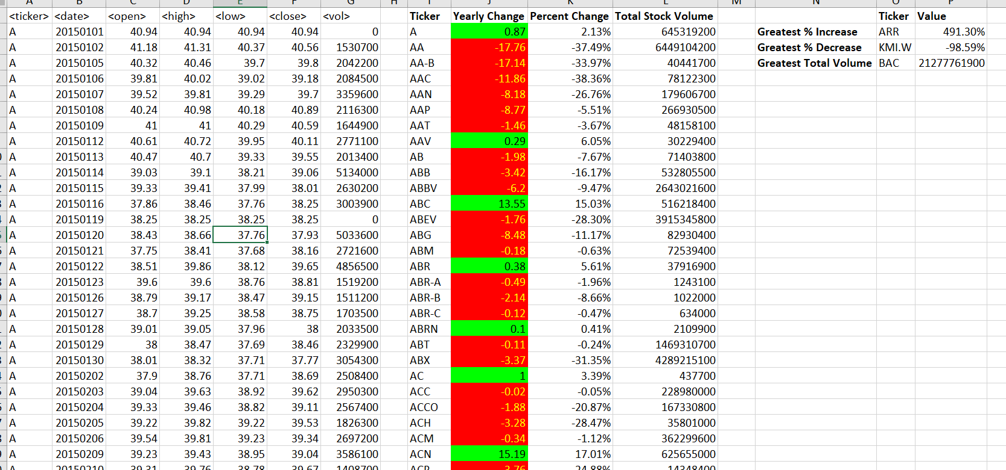

**2016**

